# Q4.

# BSI DSG

DOCUMENTS RÉPONSE

t

t

# CMM

t

# BUS

**Q6.**

**t**

0 1 2 3 4 5 6 7 8 9 10 11 12

Figure 1 : Arbitrage

|  |  |  |  |  |  |  |  |  |  |  |  |  |  |  |
| --- | --- | --- | --- | --- | --- | --- | --- | --- | --- | --- | --- | --- | --- | --- |
|  | **S O**  **F** | Champs identificateur (0x7C1) | | | | | | | | | | |  | |
| Trame sans bourrage |  |  |  |  |  |  |  |  |  |  |  |  |
| Trame avec bourrage |  |  |  |  |  |  |  |  |  |  |  |  |  |  |

Tableau 1 : Bits de bourrage

# Q7.

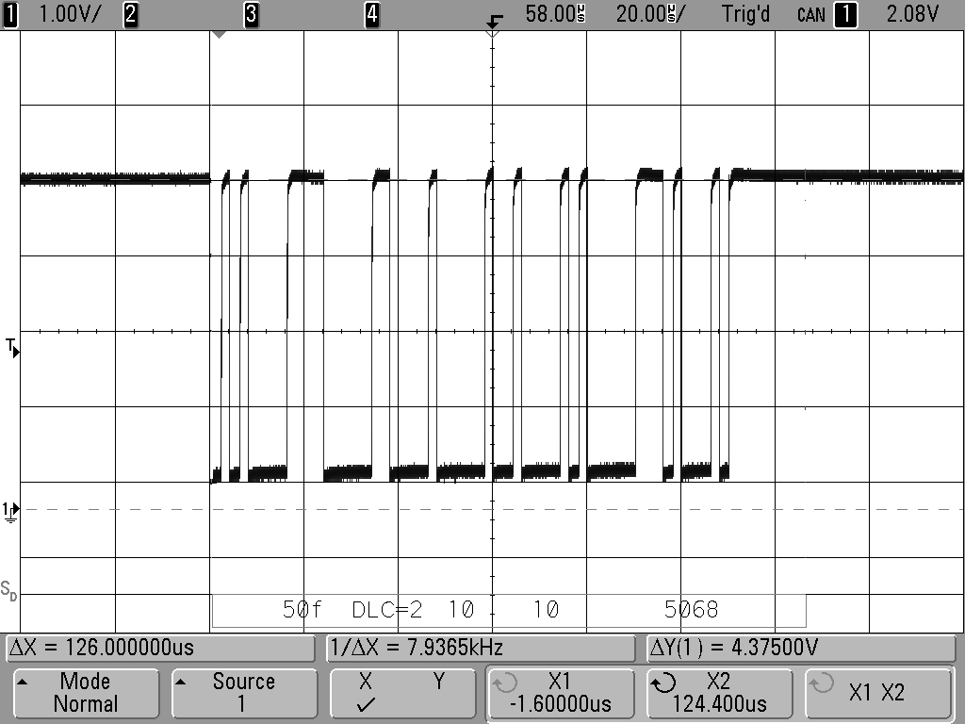

Longueur de la trame = 63 bits

**Q8.**

Figure 2 : Relevé trame CAN